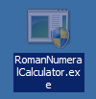**Roman Numeral Converter Documentation:**

**Directions:**

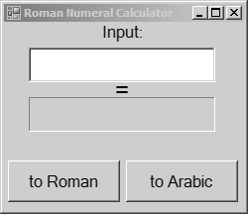Our converter was made with simplicity in mind, so that usage is as quick and efficient as possible. To open the Roman Numeral Converter, please drag the exe file that you’ve downloaded to wherever you can easily find it. Then, double-click the file (shown on the right for clarity) and a window should appear.   
  
The popup window (shown on the right) should be simple to use, and easy to follow. However, there are a few things to keep in mind, such as:  
  
- Input values should be limited between 0 and 3999.  
- Roman numerals can only contain I, V, X, L, C, D, and M.   
- Roman numerals cannot be lowercase  
- Arabic values can only contain whole numbers  
- Arabic numbers can only be translated to Roman numerals  
- Roman numerals can only be translated to Arabic numbers.

****The three icons in the top right corner of the form are as follows: The first icon, the line, is for minimizing the window into the system tray. This button will make the window disappear until you click the minimized icon in the tray to bring it back up. The second icon, the box, is for maximizing the window. Clicking this will make the program take up the entire screen. Finally, the third button, the X, is for exiting the program. Exiting the program should bring you back to your desktop, and if you need to open it back up again, just follow the instructions in the beginning and double click the exe file again.

**Use:**

This program was intended for use as a learning tool, in both home and educational environments. Not only does it properly translate over 3 thousand values between Roman numerals and Arabic numbers, but it intentionally accepts incorrect values so that one can discover and learn the proper values by converting it a second time. For example: If a user were to input the incorrect Roman numeral “XXXX”, they would get a result of “40”.

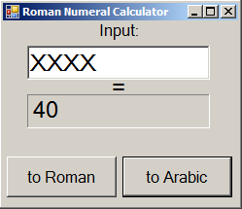 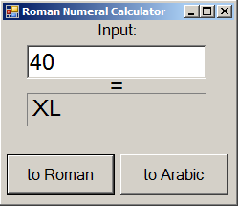 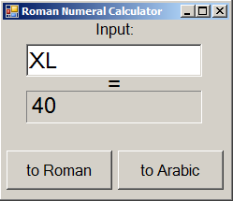

However, if they were to then type “40” into the input box and convert it back into Roman numerals, they would then get the correct value of “XL”.

**Comments, concerns or questions?**For any questions or help regarding this application, please contact us!  
**Phone:** 1-800-FAKE-NUMBER **Email:** TotallyRealCompanyEmail@mail.com

**Patch Notes:**  
As of version 1.2 on 4/4/2018, the following bugs have been fixed:

* Error Messages are now specified between:
  + Roman to Arabic conversion input
  + Arabic to Roman conversion input
  + Values more than 4000
* Form is now properly labeled
* Labels and Button Aesthetics have been fixed
* Comic sans has not been added, despite the programmers *intense urge.*
* Program no longer initiates self-destruct sequence upon exit. (RIP Jimothy in accounting)